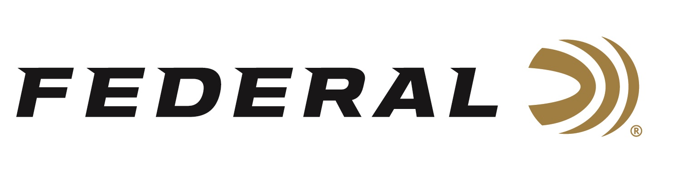

FOR IMMEDIATE RELEASE

Gun Talk with Hickok on “It’s Federal Season” Podcast

ANOKA, Minnesota – April 21, 2022 – Federal’s “It’s Federal Season” connects with one the most popular YouTube figures to talk guns, ammunition, and making videos. Guest host Julie Golob connects with Hickok45 for an in-depth conversation on a variety of topics including Hickok’s entry into the gun industry, what ignited his YouTube channel, and a day in the life of Hickok45. This is an epic episode between two of the firearm industry’s best Ambassadors.

“Being an average guy is the reason that I believe we’ve excelled,” Hickok45 told podcast host Julie Golob. Hickok, a retired middle school English teacher, started his run as a prolific content provider in 2007 and has seen a lot of changes during his tenure of making videos. “I take a lot of pride in providing an honest look at firearms,” says Hickok45 and viewers, more than 6 million subscribers to his channel, have consumed his insights to the tune of nearly 2 billion views.

Golob and Hickok45 continue their discussion into the Tech Talk segment and Hickok45 talks about his favorite cartridges and the Federal and CCI ammunition he trusts to run this his firearms. If you don’t know Hickok45’s story, you won’t want to miss this conversation.

Episode #33 “Gun Talk with Hickok45”
https://www.federalpremium.com/this-is-federal/podcast/

For this episode, besides listening on the Federal Premium website or Talk North podcast network, you can also subscribe to Federal Ammunition’s YouTube channel (https://www.youtube.com/user/federalpremiumammo) and tune in for the discussion.

Federal Ammunition can be found at dealers nationwide or purchased online direct from Federal. For more information on all products from Federal or to shop online, visit www.federalpremium.com.

Press Release Contact: JJ Reich
Senior Manager – Press Relations
E-mail: VistaPressroom@VistaOutdoor.com

About Federal Ammunition
Federal, headquartered in Anoka, MN, is a brand of Vista Outdoor Inc., an outdoor sports and recreation company. From humble beginnings nestled among the lakes and woods of Minnesota, Federal Ammunition has evolved into one of the world's largest producers of sporting ammunition. Beginning in 1922, founding president, Charles L. Horn, paved the way for our success. Today, Federal carries on Horn's vision for quality products and service with the next generation of outdoorsmen and women. We maintain our position as experts in the science of ammunition production. Every day we manufacture products to enhance our customers' shooting experience while partnering with the conservation organizations that protect and support our outdoor heritage. We offer thousands of options in our Federal Premium and Federal® lines-it's what makes us the most complete ammunition company in the business and provides our customers with a choice no matter their pursuit.

